Low Level Design (LLD) Swiggy Bangalore Data Analysis



## Revision Number - 1.2

**Last Date of Revision - 03/07/2022**

**Shashank Shekhar Nishad**

**Document Control**

|  |  |  |  |
| --- | --- | --- | --- |
| **Date** | **Version** | **Description** | **Author** |
| 19/06/2022 | 1.0 | Introduction, Problem Statement | Shashank Nishad |
| 26/06/2022 | 1.1 | Dataset Information, Architecture Description | Shashank Nishad |
| 03/07/2022 | 1.2 | Final Revision | Shashank Nishad |
|  |  |  |  |

**2**

**Low level document**

Contents

1. Introduction........................................................................................................... 04

1.1 What is Low-Level Design Document? .............................................................. 04

1.2 Scope .................................................................................................................04

2. Architecture ......................................................................................................... 05

3. Architecture Description ....................................................................................... 08

3.1 Data Description .................................................................................................08

3.2 Web Scrapping ...................................................................................................08

3.3 Data Transformation .......................................................................................... 08

3.4 Data insertion into database .............................................................................. 08

3.5 Connection with SQL server .............................................................................. 08

3.5 Export Data from database .................................................................................12

3.6 Deployment ........................................................................................................ 12

4. Unit test cases ......................................................................................................15

4 SWIGGY DATA ANALYSIS

4 LOW LEVEL DESIGN

1. Introduction

1.1 What is Low-Level design document?

## Why this Low-Level Design Document?

The purpose of this document is to present a detailed description of the heart disease prediction analysis technique. It will explain the necessary steps which have to be followed before any analysis can begin. The document would also describe the algorithms and techniques used to predict the presence and absence of the heart disease and present a comparative result for the same. LLD describes the class diagrams with the methods and relations between classes and programs specs. It describes the modules so that the programmer can directly code the program from the document. This document is intended for both the stakeholders and the developers of the system and will be proposed to the higher management for its approval.

The LLD will be focusing on the below objectives:

* Problem Understanding.
* Data Acquisition.
* Data Pre-Processing and Exploratory Analysis
* Development of models
* Auditing accuracy and retrain if require
* Finalizing the model
* Dashboard report for important activities

1.2 Scope

Low-level design (LLD) is a component-level design process that follows a step-by-step refinement process. The process can be used for designing data structures, required software architecture, source code and ultimately, performance algorithms. Overall, the data organization may be defined during requirement analysis and then refined during data design work.

Project introduction

Food Industry is one of the most common now a day most of the people buy online food they have order online so we have a data of Swiggy Bangalore outlet data and I worked on that data.

The food industries collect huge amounts of data that contain some hidden information, which is useful for making effective decisions. For providing appropriate results and making effective decisions on data, some data science techniques need to be used. The data analysit predicts the inside from the data. It enables significant knowledge.

**Constraints**

Our analysis is done based on a limited dataset provided for a specific (5) features affecting food industry. The analysis does not take into account any external interventions like underlying disease, type of medication used, lifestyle patterns, BMI value etc.

**Risks**

Document specific risks that have been identified or that should be considered.

**Out of Scope**

Delineate specific activities, capabilities, and items that are out of scope for the project.

1. **Technical specifications**

**Dataset**

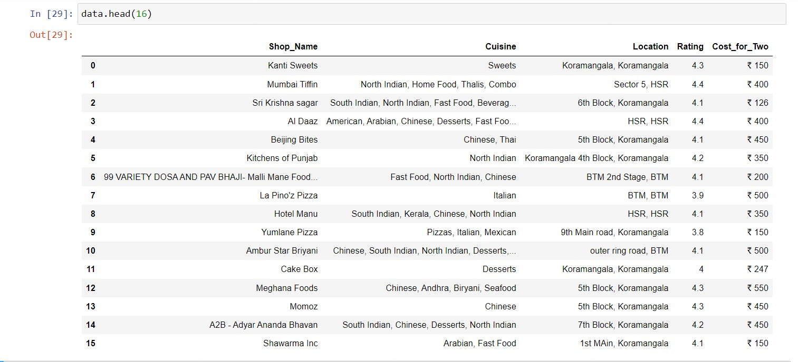

**Problem statement**

The online food ordering market includes foods prepared by restaurants, prepared by independent people, and groceries being ordered online and then picked up or delivered. The first online food ordering service, World Wide Waiter (now known as Waiter.com), was founded in 1995. Online food ordering is the process of ordering food from a website or other application. The product can be either ready-to-eat food or food that has not been specially prepared for direction consumption.

**2. Architecture**

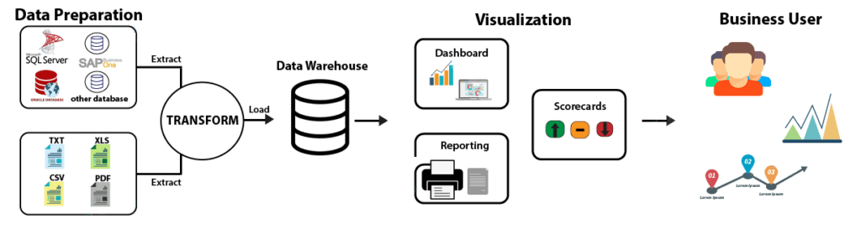

**Tableau Server Architecture**

**Architecture Description**

* 1. **Architecture Description**
     1. **Raw Data Collection** The Dataset was taken from iNeuron’s provided Project Description Document.

[ETL - Google Drive](https://drive.google.com/drive/folders/1FkmFVL8wlJmQWP1z52TD8PlhOJhitTyI)

### Data Pre-Processing

Before building any model, it is crucial to perform data pre-processing to feed the correct data to the model to learn and predict. Model performance depends on the quality of data feeded to the model to train.

This Process includes-

* + - 1. Handling Null/Missing Values
      2. Handling Skewed Data
      3. Outliers Detection and Removal

### Data Cleaning

Data cleaning is the process of fixing or removing incorrect, corrupted, incorrectly formatted, duplicate, or incomplete data within a dataset.

* + - 1. Remove duplicate or irrelevant observations
      2. Filter unwanted outliers
      3. Renaming required attributes

### Exploratory Data Analysis (EDA)

Exploratory Data Analysis refers to the critical process of performing initial investigations on data to discover patterns, spot anomalies, test hypothesis

and to check assumptions with the help of summary statistics and graphical representations.

### Reporting

Reporting is a most important and underrated skill of a data analytics field. Because being a Data Analyst you should be good in easy and self-explanatory report because your model will be used by many stakeholders who are not from technical background.

* + - 1. High Level Design Document (HLD)
      2. Low Level Design Document (LLD)
      3. Architecture
      4. Wireframe
      5. Detailed Project Report
      6. Power Point Presentation

### Modelling

Data Modelling is the process of analysing the data objects and their relationship to the other objects. It is used to analyse the data requirements that are required for the business processes. The data models are created for the data to be stored in a database. The Data Model's main focus is on what data is needed and how we have to organize data rather than what operations we have to perform.

### Deployment

We created a Power BI Dashboard

